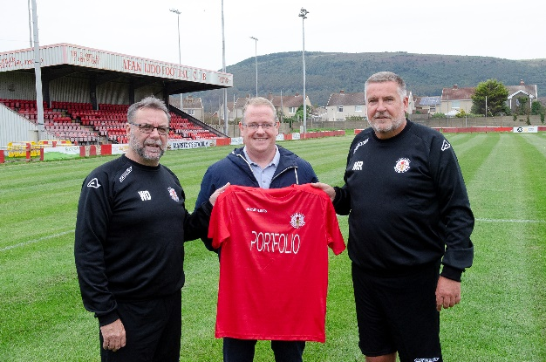
Afan Lido FC are delighted to welcome a brand new kit sponsor to the club for the 2019/20 campaign.

Swansea-based Portfolio Financial Consultancy portfolio.org.uk have agreed a deal with the Seasiders this season and they will be adorning the shirts of the senior set-up in the newly-formed JD Cymru South.

The financial management company have expressed their delight at linking up with Afan Lido and are hoping to establish a long-running partnership in assisting the club in their bid for success.

Operations Director of Portfolio Financial Consultancy, Gareth Jones, commented: "I'm very optimistic about our partnership. Afan Lido is a club that is part and parcel of the community and has a longstanding tradition of mixing experience with homegrown youth which we are keen to support.
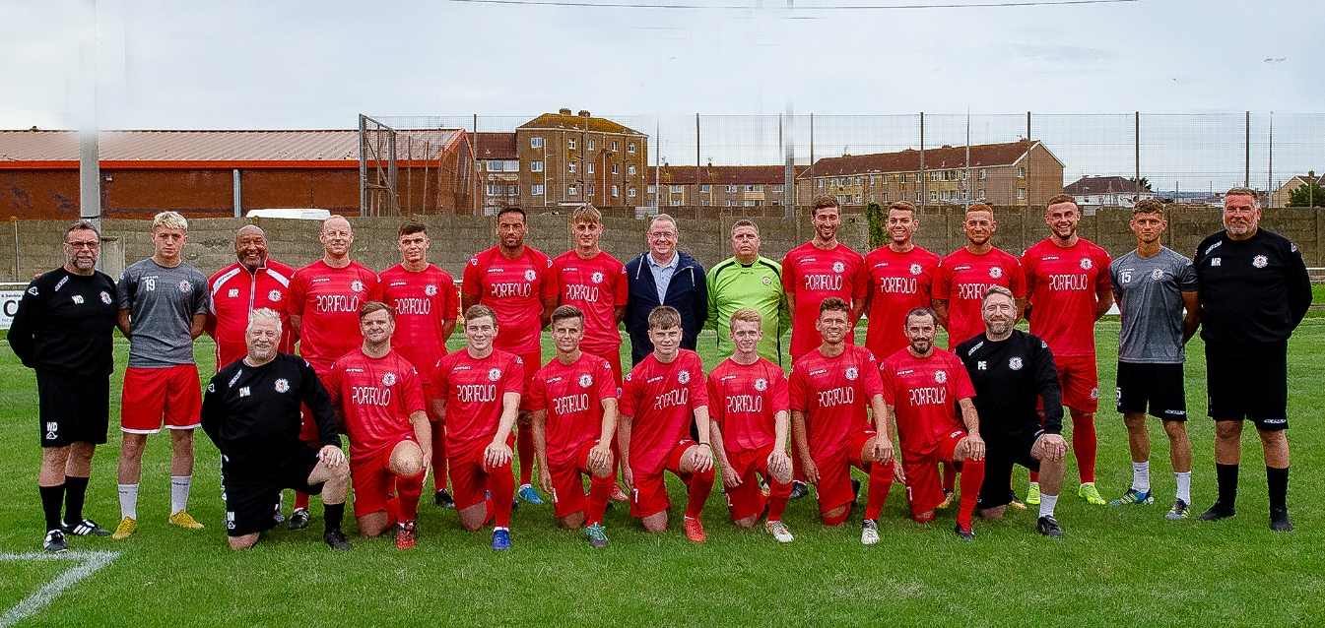
"My personal passion is football so this is a fantastic opportunity to join forces with a well-respected local club and we're hoping to have a great season."

Club General Manager Mark Robinson commented: "We're thrilled to have Portfolio Financial Consultancy on board this season.

"We have been delighted to welcome them to the club. They share our vision for success at Afan Lido and this will be a fantastic opportunity for everyone involved."

